LED Dimmable High CRI

TCP’s High CRI line offers exceptional color consistency and color rendering to enhance colors of focal points from lamp to lamp.
®

Limitless options for the following applications:

- Track Lights
- Display Lights
- General Lighting
- Table and Floor Lamps
- Ceiling Fixtures and Sconces
- Outdoor Fixtures that protect lamps from the elements
- Recessed , 4”, and 5”/6” downlight applications

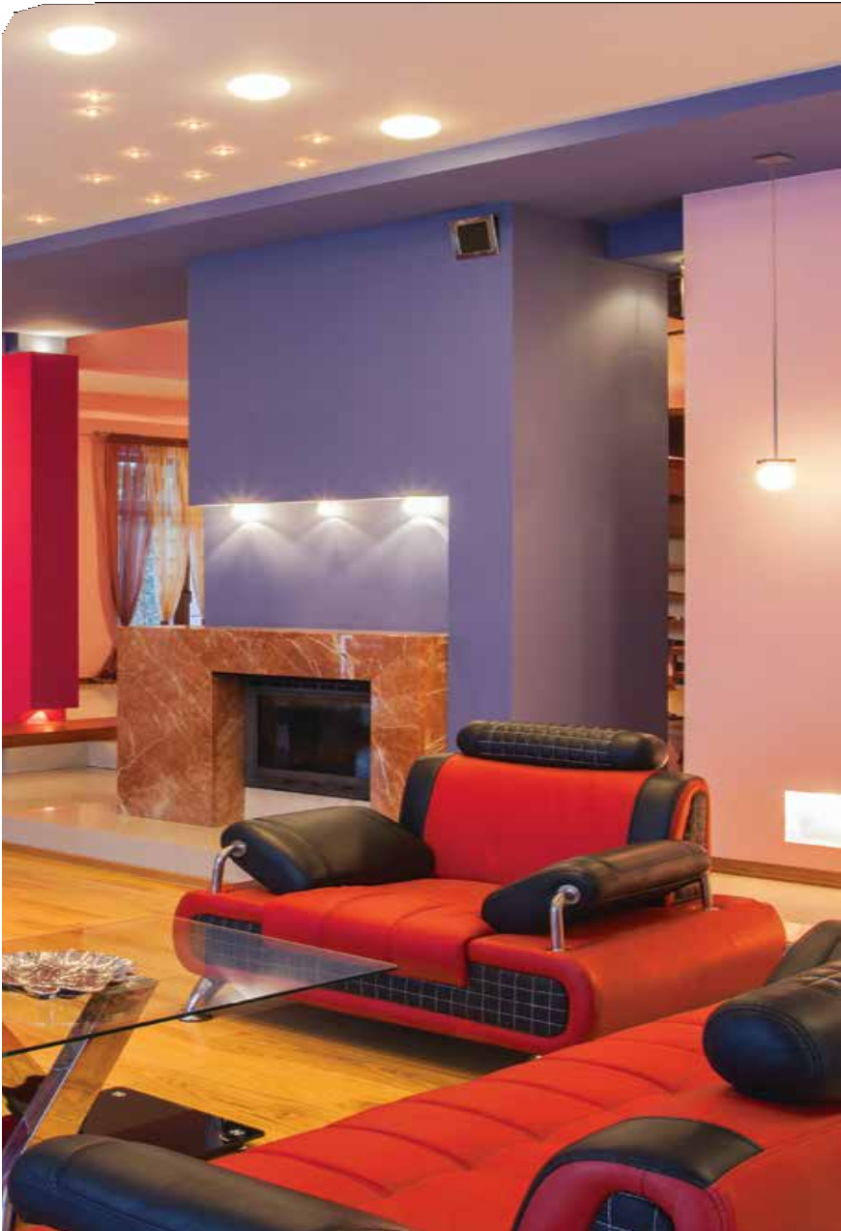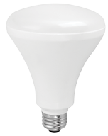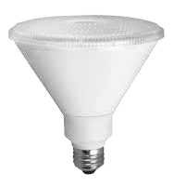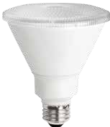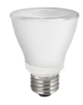
®

Great features and benefits:

- Excellent color consistency (CRI)
- High CRI lamps available in PARs, BRs, A-Lamps and Recessed Retrofit Downlights
- Smooth, uniform dimming
- 90W, 75W, 65W, 60W and 50W replacements
- Long Life: 25,000 hours Recessed Retrofits: 35,000 hours
- 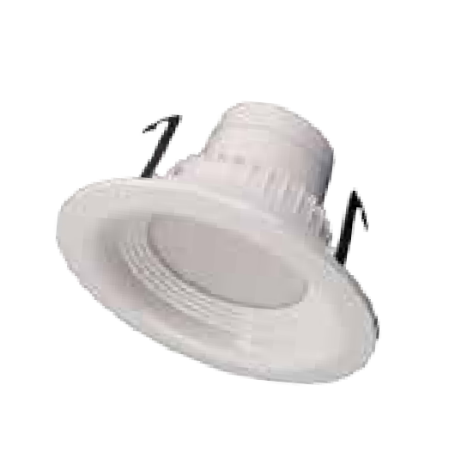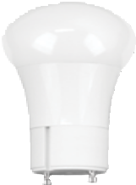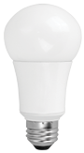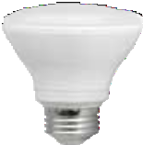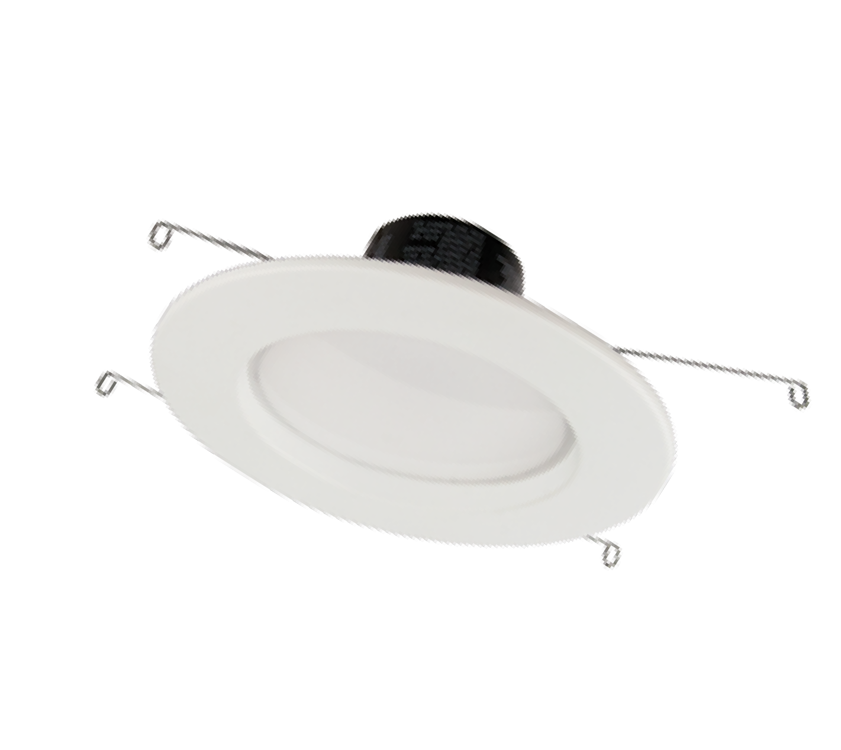Available in 2700K and 3000K

CRI R9

we know light.™
TCP®
325 Campus Dr. | Aurora, Ohio 44202 | P: 800-324-1496 | tcpi.com
©TCP MARCH 2017/WF40203

LED Dimmable High CRI Specifications

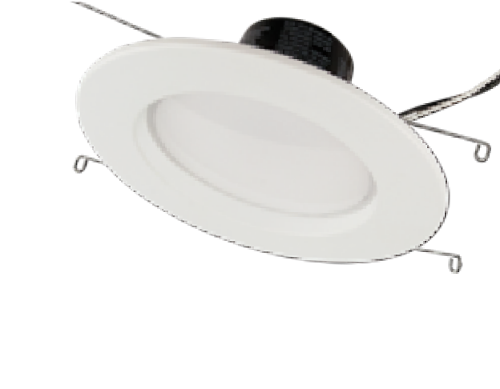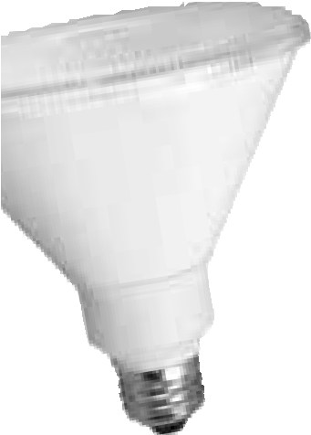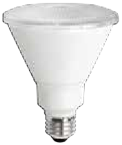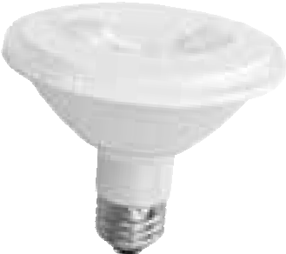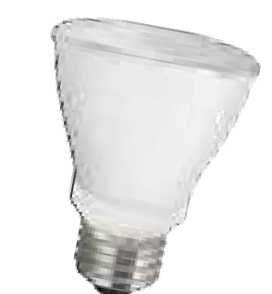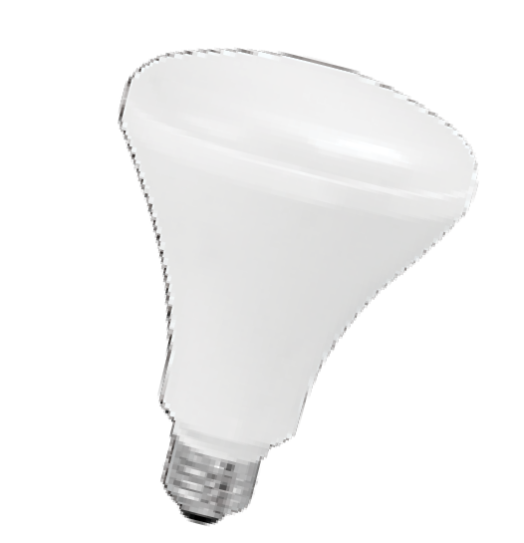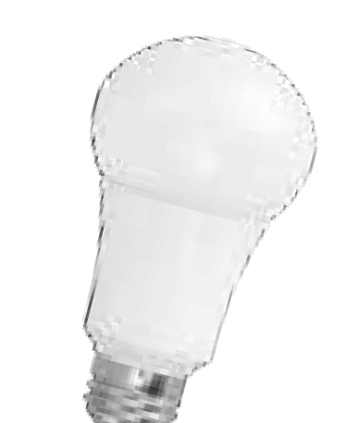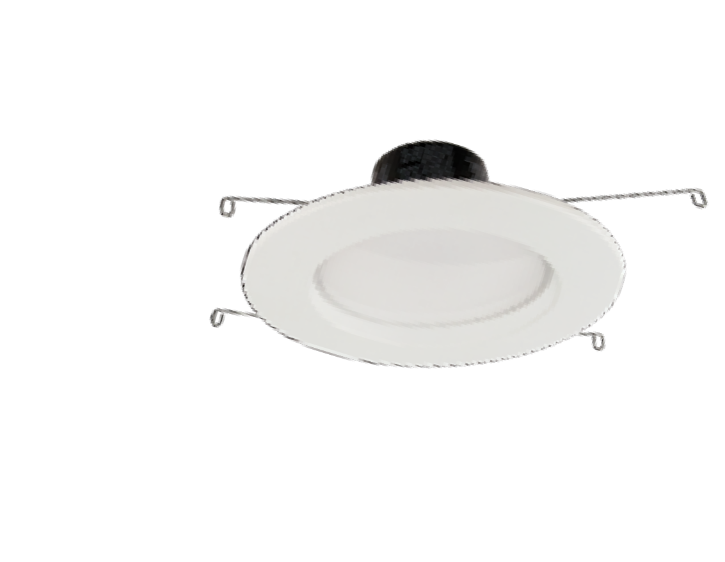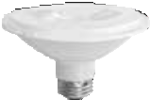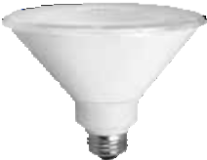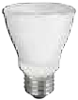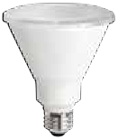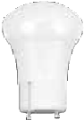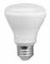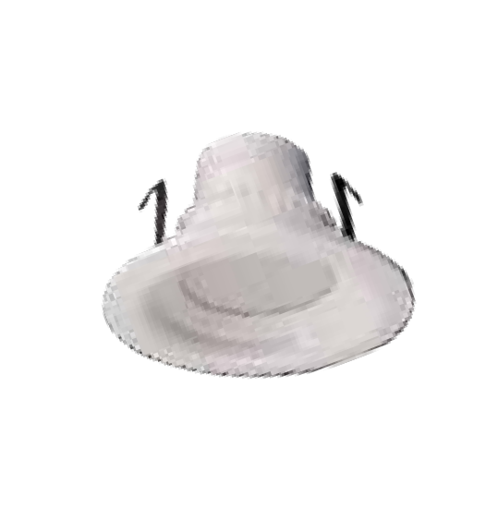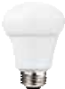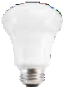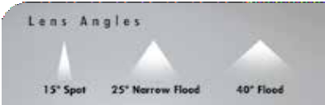Catalog Number
LED
25,000 hours average rated life, 120 volts

Notes Type
Applications:

Ideal for all dimmable applications and areas where high color rendering is desired.
✚ Recessed, 4”, and 5”/6” Retrofit Downlights
✚ Track and Display Lights
✚ Outdoor Fixtures that protect lamps from the elements
✚ General Lighting
✚ Table and Floor Lamps
✚ Ceiling Fixtures and Sconces

Features Benefits

Excellent Color Consistency and CRI*
Enhances colors of focal point while maintaining uniformity throughout lighting installation from lamp to lamp

Omni-Directional Light Distribution

Up to 80% less energy than halogen alternatives
Instant energy savings

Long life
Minimizes replacement and maintenance costs

Smooth, clean outside housing
Seemlessly blends into lighting applications

Very low heat generation
UL approved for damp location and enclosed fixtures

Shatter resistant
Perfect for sensitive display lighting such as art galleries

Lower the risk of injury and breakage
Can be used outdoors when protected from elements, withstands humidity indoors/outdoors

3.8"

3.0"

5.2"

5.3"

4.8"

4.8"

3.8"

3.5"

3.8" 2.5"

3.5"
7.5"
5"/6" Recessed Retrofit Downlight
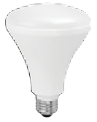
3.8"

5.4"

3.5"

2.5"

4" Recessed Retrofit Downlight

2.6"
2.6"
4.5"
4.6"

 |  |  |  |  |  |  |  |  |  | Omni-Directional | GU24
PAR38 | PAR30LN |  | PAR30SN |  | PAR20 | BR30 |  | R20 |  | A-LAMP | A-LAMP
Specifications
 | PAR38 | PAR30LN | PAR30SN | PAR20 | BR30 | R20 | A19 |  | 5”/6” Downlight |  | 4” Downlight
Input Line Voltage: | 120 VAC | 120 VAC | 120 VAC | 120 VAC | 120 VAC | 120 VAC | 120 VAC |  | 120 VAC |  | 120 VAC
Input Power | 17 W / 14W | 14 W / 12 W | 12 W | 10 W | 9 W / 12 W | 7 W | 11 W |  | 11 W /14 W |  | 9 W
Input Line Frequency | 50/60HZ | 50/60HZ | 50/60HZ | 50/60HZ | 50/60HZ | 50/60HZ | 50/60HZ |  | 50/60HZ |  | 50/60HZ
Lamp Life (Rated) | 25,000 hrs | 25,000 hrs | 25,000 hrs | 25,000 hrs | 25,000 hrs | 25,000 hrs | 25,000 hrs |  | 35,000 hrs |  | 35,000 hrs
Minimum Starting Temp | -30ºC | -30ºC | -30ºC | -30ºC | -30ºC | -30ºC | -30ºC |  | -30ºC |  | -30ºC
Maximum Operating Temp | 40ºC | 40ºC | 40ºC | 40ºC | 40ºC | 40ºC | 40ºC |  | 40ºC |  | 40ºC

LED Dimmable High CRI Specifications
Smooth Uniform Dimming

(min)
Item # | Description | Voltage | Wattage | Replacement | Lumens LPW | CBCP  (est) | M.O.L.  (inches) | Diameter (inches) | CCT CRI* | R9* (min)
PAR38
LED17P38D27KFL95 | Dimmable 17W Smooth PAR38 - 2700K 40º | 120 | 17 | 90 | 1050 61.8 | 1533 | 5.3 | 4.8 | 2700K 90 | 50
LED17P38D27KNFL95 | Dimmable 17W Smooth PAR38 - 2700K 25º | 120 | 17 | 90 | 1050 61.8 | 3698 | 5.3 | 4.8 | 2700K 90 | 50
LED17P38D27KSP95 | Dimmable 17W Smooth PAR38 - 2700K 15º | 120 | 17 | 90 | 1050 61.8 | 8285 | 5.3 | 4.8 | 2700K 90 | 50
LED17P38D30KFL95 | Dimmable 17W Smooth PAR38 - 3000K 40º | 120 | 17 | 90 | 1050 61.8 | 1533 | 5.3 | 4.8 | 3000K 90 | 50
LED17P38D30KNFL95 | Dimmable 17W Smooth PAR38 - 3000K 25º | 120 | 17 | 90 | 1050 61.8 | 3698 | 5.3 | 4.8 | 3000K 90 | 50
LED17P38D30KSP95 | Dimmable 17W Smooth PAR38 - 3000K 15º | 120 | 17 | 90 | 1050 61.8 | 8285 | 5.3 | 4.8 | 3000K 90 | 50
LED14P38D27KNFL95 | Dimmable 14W Smooth PAR38 - 2700K 25º | 120 | 14 | 90 | 900 64.2 | 3698 | 5.3 | 4.8 | 2700K 90 | 50
LED14P3827KNFL95 | Non-Dimmable 14W Smooth PAR38 - 2700K 25º | 120 | 14 | 90 | 900 64.2 | 3698 | 5.3 | 4.8 | 2700K 90 | 50
PAR30
LED14P30D27KFL95 | Dimmable 14W Smooth PAR30 - 2700K 40º | 120 | 14 | 75 | 900 64.2 | 1315 | 4.8 | 3.8 | 2700K 90 | 50
LED14P30D27KNFL95 | Dimmable 14W Smooth PAR30 - 2700K 25º | 120 | 14 | 75 | 900 64.2 | 2910 | 4.8 | 3.8 | 2700K 90 | 50
LED14P30D27KSP95 | Dimmable 14W Smooth PAR30 - 2700K 15º | 120 | 14 | 75 | 900 64.2 | 6155 | 4.8 | 3.8 | 2700K 90 | 50
LED14P30D30KFL95 | Dimmable 14W Smooth PAR30 - 3000K 40º | 120 | 14 | 75 | 1000 71.4 | 1315 | 4.8 | 3.8 | 3000K 90 | 50
LED14P30D30KNFL95 | Dimmable 14W Smooth PAR30 - 3000K 25º | 120 | 14 | 75 | 1000 71.4 | 2910 | 4.8 | 3.8 | 3000K 90 | 50
LED14P30D30KSP95 | Dimmable 14W Smooth PAR30 - 3000K 15º | 120 | 14 | 75 | 1000 71.4 | 6155 | 4.8 | 3.8 | 3000K 90 | 50
LED12P30D30KNFL95 | Dimmable 12W Smooth PAR30 - 3000K 25º | 120 | 12 | 65 | 650 54.2 | 2118 | 4.8 | 3.8 | 3000K 90 | 50
L10P30D2530KFLW95+* | Dimmable Wet Location 10W Smooth PAR30 - 3000K 40º | 120 | 10 | 75 | 750 75 | 1315 | 4.8 | 3.8 | 3000K 90 | 50
LED12P30SD27KFL95 | Dimmable 12W Smooth PAR30 Short Neck - 2700K 40º | 120 | 12 | 65 | 750 62.5 | 957 | 3.5 | 3.8 | 2700K 90 | 50
LED12P30SD27KNFL95 | Dimmable 12W Smooth PAR30 Short Neck - 2700K 25º | 120 | 12 | 65 | 750 62.5 | 2118 | 3.5 | 3.8 | 2700K 90 | 50
LED12P30SD27KSP95 | Dimmable 12W Smooth PAR30 Short Neck - 2700K 15º | 120 | 12 | 65 | 750 62.5 | 4481 | 3.5 | 3.8 | 2700K 90 | 50
LED12P30SD30KFL95 | Dimmable 12W Smooth PAR30 Short Neck - 3000K 40º | 120 | 12 | 65 | 750 62.5 | 957 | 3.5 | 3.8 | 3000K 90 | 50
LED12P30SD30KNFL95 | Dimmable 12W Smooth PAR30 Short Neck - 3000K 25º | 120 | 12 | 65 | 750 62.5 | 2118 | 3.5 | 3.8 | 3000K 90 | 50
LED12P30SD30KSP95 | Dimmable 12W Smooth PAR30 Short Neck - 3000K 15º | 120 | 12 | 65 | 750 62.5 | 4481 | 3.5 | 3.8 | 3000K 90 | 50
PAR20
LED10P20D27KFL95 | Dimmable 10W Smooth PAR20 - 2700K 40º | 120 | 10 | 50 | 500 50.0 | 593 | 3.5 | 2.5 | 2700K 90 | 50
LED10P20D27KNFL95 | Dimmable 10W Smooth PAR20 - 2700K 25º | 120 | 10 | 50 | 500 50.0 | 1179 | 3.5 | 2.5 | 2700K 90 | 50
LED10P20D30KFL95 | Dimmable 10W Smooth PAR20 - 3000K 40º | 120 | 10 | 50 | 500 50.0 | 593 | 3.5 | 2.5 | 3000K 90 | 50
LED10P20D30KNFL95 | Dimmable 10W Smooth PAR20 - 3000K 25º | 120 | 10 | 50 | 500 50.0 | 1179 | 3.5 | 2.5 | 3000K 90 | 50
BR30
LED12BR30D27K95 | Dimmable 12W Smooth BR30 - 2700K | 120 | 12 | 65 | 850 70.8 | – | 5.4 | 3.8 | 2700K 90 | 50
LED12BR30D30K95 | Dimmable 12W Smooth BR30 - 3000K | 120 | 12 | 65 | 875 72.9 | – | 5.4 | 3.8 | 3000K 90 | 50
LED10BR30D27K95 | Dimmable 10W Smooth BR30 - 2700K | 120 | 10 | 65 | 650 65.0 | – | 5.4 | 3.8 | 2700K 90 | 50
LED10BR30D30K95 | Dimmable 10W Smooth BR30 - 3000K | 120 | 10 | 65 | 675 67.5 | – | 5.4 | 3.8 | 3000K 90 | 50
L9BR30D2527K95+*  R20 | Dimmable 9W Smooth BR30 - 2700K | 120 | 9 | 65 | 650 72.2 | – | 5.4 | 3.8 | 2700K 90 | 50
L7R20D2527K95+* Dimmable 7W Smooth R20 - 2700K 120 |  |  | 7 | 50 | 525 75.0 | – | 3.5 | 2.5 | 2700K 90 | 50
A-Lamp
LED11A19DOD27K95+*  LED11A19DOD30K95+* | Dimmable 11W Omni-Directional A19 - 2700K Dimmable 11W Omni-Directional A19 - 3000K | 120  120 | 11  11 | 60  60 | 800 72.7  800 72.7 | –  – | 4.5  4.5 | 2.6  2.6 | 2700K 90  3000K 90 | 50  50
LED11A19GUDOD27K95+  LED11A19GUDOD30K95+ | * Dimmable 11W Omni-Directional A19 - 2700K  * Dimmable 11W Omni-Directional A19 - 3000K | 120  120 | 11  11 | 60  60 | 800 72.7  800 72.7 | –  – | 4.6  4.6 | 2.6  2.6 | 2700K 90  3000K 90 | 50  50
Recessed Retrofit
LED14DR5627K95 | Dimmable 14W 5"/6" Recessed Retrofit Downlight - 2700K | 120 | 14 | 65 | 700 50.0 | – | 3.8 | 7.5 | 2700K 90 | 50
LED14DR5630K95 | Dimmable 14W 5"/6" Recessed Retrofit Downlight - 3000K | 120 | 14 | 65 | 700 50.0 | – | 3.8 | 7.5 | 3000K 90 | 50
L11DR56D3527K95+ | Dimmable 11W 5"/6" Recessed Retrofit Downlight - 2700K | 120 | 11 | 65 | 700 63.7 | – | 3.8 | 7.5 | 2700K 90 | 50
L11DR56D3530K95+ | Dimmable 11W 5"/6" Recessed Retrofit Downlight - 3000K | 120 | 11 | 65 | 750 68.2 | – | 3.8 | 7.5 | 3000K 90 | 50
L9DR4D3527K95+ | Dimmable 9W 4" Recessed Retrofit Downlight - 2700K | 120 | 9 | 50 | 550 61.1 | – | 3.0 | 5.2 | 2700K 90 | 50
L9DR4D3530K95+ | Dimmable 9W 4" Recessed Retrofit Downlight - 3000K | 120 | 9 | 50 | 550 61.1 | – | 3.0 | 5.2 | 3000K 90 | 50

C R E A T I N G B E A U T Y

TCP has a 20-year history in energy-efficient lighting.
Thanks to our cutting edge technology and manufacturing expertise, we have shipped billions of high quality lamps and our

integrated technology and manufacturing
provides expedited time-to-market. With TCP, you can count on unique lighting products designed to meet very specific needs – lighting that transforms your surroundings and envelopes you in warmth – lighting that generates beauty with every flip of the switch.

